CAPE TOWN FIRE & MAINTENANCE SERVICES
SERVICE CERTIFICATE
ANNUAL SERVICE AND SUPPLY OF FIRE EXTINGUISHERS, HOSE REELS & HYDRANTS IN ACCORDANCE WITH SANS 1475 PART 1 & 2 – GOOD WORKING CONDITION
{{NAME}}
  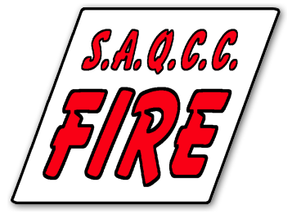 |  | SAQCC NO’S: 18/063 – 01/496 – 01/261  service date: {{DATE}} DUE DATE: {{NEXTDATE}}

UNIT 3, PONTAC ROAD, SAXENBURG PARK 1, BLACKHEATH, KUILSRIVER. TEL: 021 981 0275 CELL: 064 859 8186 EMAIL: ANDRE@FIREMAINTENANCE.CO.ZA

